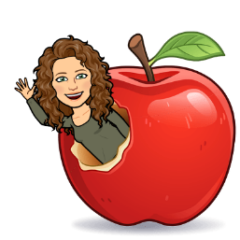
I wanted to introduce myself…my name is Tracy Russell, and I am very excited to be part of the SPS community. With over two decades of experience in education within EIPS, I bring a wealth of knowledge and a passion for fostering positive relationships within the learning environment. I firmly believe in the power of collaboration and community engagement to create an environment where every student can thrive. Building strong connections with students, parents, and the community is at the core of my approach, and I am eager to get to know and work alongside each member of the SPS community and your family. Feel free to reach out via email at tracy.russell@eips.ca or by phone at 780.998.2747 (ext. 4674) if you have any questions or would like to connect.

April’s Edition of the Counsellor’s Corner

